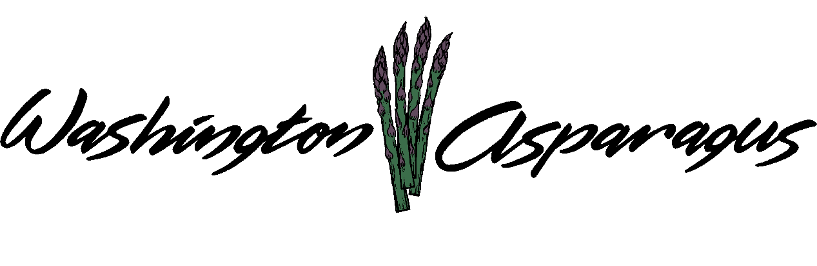

WASHINGTON ASPARAGUS COMMISSION

Asparagus Commission Office
Prosser, WA 99330
January 12th, 2017
Gary Larsen, Chair, Presiding.

Chair Gary Larsen called the meeting to order at 1:00 pm.

Introduction

Present: Rebecca Weber, Steve Thomas, Jeff Muse, Bryan Lynch, Gary Larsen, Keith
Middleton, Jon Nishi, Gary Johnson and Norm Inaba

Administration Staff Present: Alan Schreiber, Lori Anderson and Tiffani Deal.

Guests present: Jim Middleton

Elections

Chair Gary asks if anyone would make a motion about selecting officers for the Commission.

Jon made a motion to re-nominate the existing Chair, the Vice Chair and the Treasurer to remain in the same positions. Gary Johnson seconded the motion. Motion passed unanimously.

Approval of Minutes

Chair Gary asked Rebecca what we should do to make changes in our minutes. Rebecca would like to see the minutes with just the basic information without too much detail. Gary wondered if we want it to be briefer than it currently is or will that be problematic for the Commission. Key discussions and motions are the most important items to be written down. Rebecca will send Alan and Lori the corrected minutes as she feels that they should be.

Chair Gary asked for approval of meeting minutes.

The minutes will be amended due to the misspelling of Phil Clouse and Bill Middleton.

Norm Inaba made a motion to approve the minutes with the two corrections,
Keith Middleton seconded the motion. Motion to approve previous meeting minutes
passed with the two corrections. Minutes from November 7, 2016.

Budget

Alan went over the budget for the upcoming 2017 year. Research has been increased from last year. We have the largest roll over money from the assessments. Alan went over all other costs that we have budgeted for the year of 2017.

Bryan Lynch made the motion to approve the budget. Jon Nishi seconded the motion. Motion passed unanimously.

Financial Report:

Alan went over budget and expenditures of 2016, explaining where the Commission funds have been spent and what is left in the budget to roll over into the 2017 budget. Where we spent the money since the last Commission meeting was the next topic. Keith asked about the $8000 invoice he sent in for mechanization, Tiffani explained that it was not received in 2016. Rebecca would like to make sure that this invoice has a line item describing what the Commission is being billed for. This money will come out of the specialty project for mechanization from the 2017 budget. Alan finds value in the trips the Commission does for the asparagus industry. There is a request to increase the Administrative Contract fee for the upcoming 2017 year. Bryan asked why we have such a large carry over; Alan explained it is from not expending money on several of the Commission projects in 2016. Jim wanted to know why the reserve money had decreased from $200,000 to $100,000. The Commission spent $100,000 on Ken Haas Harvester several years ago, but we kept $100,000 as the board designated reserve. .Gary wants to know why the board designated reserve money is part of the budget, why do we have this amount of $100,000. Bryan thought we could add that to the carry over amount. All of this money has to be insured.

Chair Gary asks if there are any questions regarding the Financial Report and asked for approval to pass the 2016 Financial Report.

Keith Middleton made the motion to pass the Financial Report. Jon Nishi seconded the motion. All in favor, motion passed unanimously.

Baker & Giles

Tiffany handed out the accounting review report to all the Commissioners. All of the past recommendations by the accounting firm have been implemented and addressed. There were no recommended changes for the WAC finances. (This is the best review from the accounting firm the Commission has received since 2001.)

Trade and Legislative

Charlie Brown has been hired to do legislative monitoring for the WAC in Olympia; he submitted two proposals. Alan received them and has let the Commission know what they are. Monitoring all legislation that affects the asparagus industry will cost $9,000. To increase the amount of time he spends on asparagus issues Charlie would increase his fee to $16,000. Bryan asked if the Blueberry Commission does legislative monitoring; no they do not Alan tells the Commission. Steve asked if we have asked him to do anything major for our industry, the auto packing machine. (We have not.) Gary would like to take it out of the contingency fund and give it to him if some type of bill comes up that will affect the Asparagus Commission. Steve makes a point that even if we give him more funds a bill could still pass. The Commission will budget $9000 and if something changes we can increase his retainer then.

Marketing Education

Alan asked if the Commission is still interested in sending someone to PMA this year, it will be held in New Orleans from Oct.19 thru 21st 2017. Chair Gary firmly believes in going to this convention. Bryan would like the Commission to think about putting the money into promotion and marketing. Gary Johnson thinks it is very important that we send someone from the industry to this event. Alan feels the Commission is okay with giving the local promotions committee $9000. Norm asked if this includes the wine tasting, asparagus tasting in Seattle, and the Asparagus Festival. Alan would like to include to have two programs, one for the area around the TriCities and one on the West Side. Rebecca would like to clarify if the Commission is keeping the local and West Side separate or combine the two. Alan feels is it up to the marketing committee to make that decision. Alan asks the Commissioners to go over the marketing proposals. Chair Gary would like the board to decide, and then allow the committee to decide what firm, if any we are going to use.
The Chair asked the Commission if they want to vote or wait on this decision. Rebecca would like to put the money ($27,000) into the budget and then make the decision on what proposal to accept. Gary Johnson feels the same. A decision was made to have the Promotions Committee review the proposals make the final decision in one week. Jim would like to get someone that has knowledge of marketing to help with this decision

Research

Alan went over the past research proposals and the new proposals on asparagus. Alan would like to do a small trial on bindweed, high yield, a section 18 and an aphid trial, the variety trials and the replant disease trial. Chair Gary would like to a new project focusing on developing a new chemical layby program for asparagus.

Approval of Contracts

Kevin would like to approve the research contract with Alan Schreiber, doing business as ADG. Norm wants to makes the motion to accept the contract to do all of the research for WSU because WSU does not have the facility and staff to do research on asparagus.

Chair Gary asked for a motion to approve of the research contract.

Norm makes the motion to accept the research contract. Bryan Lynch seconds the motion. The motion passed unanimously.

Administrative Services

Gary would like to know why Alan is increasing the Administrative Contract by $5000.00. The Commission would ask Alan to verify the reasoning behind the increase.

Gary would like to know if the ADG office can be a little more prepared for our meetings with the Asparagus Commission. Gary would like Alan to come to each meeting prepared and ready.
Alan explains there is a proposal with a list of what ADG provides for the Asparagus Commission through their Administrative Services. Jeff Muse would like the other Commissioners to look at all of what Alan brings to the table along with his networking and knowledge skills.

Alan would like to have feedback from the Commission on how he is doing, Gary agreed.
Norm has an idea about getting growers in one district together and Alan meeting them as a group. It may be a good idea for the board members to also meet with more growers.

Chair Gary asked for a motion.

Norm made a motion to renew the administrative contract with the $5000 increase. Keith seconds it. Motion passed unanimously.

Cascade Government

Chair Gary Asked for an approval of the Cascade Government Contract.

Bryan made the motion to approve the contract with Cascade Government Affairs.
Norm seconded the motion. Motion passed unanimously.

Adoption of Budget

Keith made a motion to pass the budget with the change of adding $8000 for mechanization and reduce the special project to $28,183. Steve Thomas seconded. Motion passed unanimously.

Public Comment

Jeff was wondering about a federal representative. Alan said we used to do this in combination with California and Michigan.

Chair Gary wanted to know if there was any other business.

Keith went over his plan for the machine and would like the Commissioners to know that they have access to the Ken Wall asparagus harvesting cart.

Meeting Adjourned at 4:00 pm.

.

.

