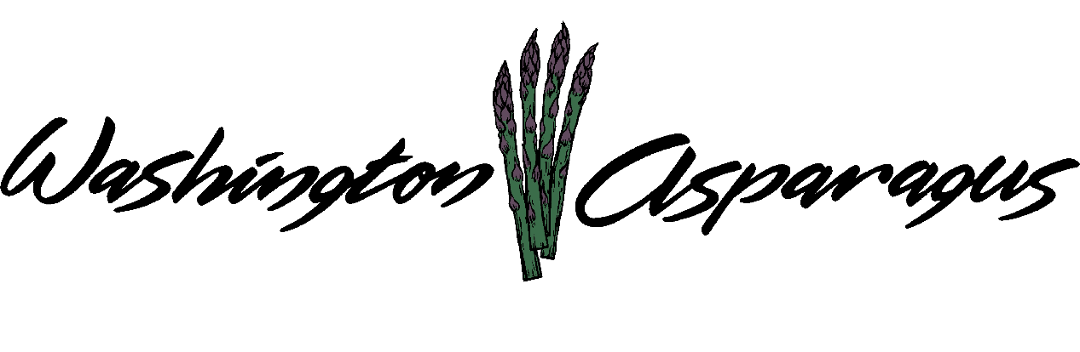

WASHINGTON ASPARAGUS COMMISSION

Asparagus Commission Office
WSU Prosser, WA
Jan. 13, 2016
Gary Larsen, Chair, Presiding.

Interim Chairman Jeff Muse called the meeting to order at 2:13 PM

Introduction

Present: Rebecca Weber, Steve Thomas, Jeff Muse, Gary Larsen, Norm Inaba, Jeff Muse, Jon Nishi, Gary Johnson.

Administration Staff Present: Alan Schreiber, Heather Stiegelmeyer, Tiffani Deal.

Guests present: Bud Lacoti, Jim Middleton, Bill Middleton, Keith Middleton

Approval of Minutes

Interim Chairman Jeff Muse asked for approve of previous meeting minutes.

Gary Larsen made the motion to approve the previous meeting minutes. Norm Inaba seconded the motion. Motion passed unanimously.

Elections

Alan stated we have a vacancy for District 3. The board will appoint someone to this position. We have two people who are interested in this position. Bud Locati and Keith Middleton.

Interim Chairman Muse asked for a motion to approve Bud Locati and Keith Middleton for consideration.

Norm Inaba made a motion to vote on possible appointees. Gary Larsen seconded motion. Motion passed unanimously.
Candidate introductions: Bud Locati and Keith Middleton.

A vote was held to determine the board position for District 3. Keith Middleton was elected.

Interim Chairman asked for a motion to appoint Keith Middleton to the board for district 3.

Gary Larsen made the motion to appoint Keith Middleton to the board. Jon Nishi seconded motion. Motion passed unanimously.

Interim Chairman stated we need to elect a new chairman, vice chair and treasurer.

Chairman

Norm Inaba made the motion to nominate Jeff Muse for chair. Bryan Lynch seconded.
Keith Middleton made a motion to nominate Gary Larsen for chairman. Norm Inaba seconded.

Rebecca Weber moved to stop nomination. Bryan Lynch seconded.

Interim Chairman asked if any additional discussion. Both candidates agreed to accept the nomination.

Interim Chairman announced new chairman is Gary Larsen. Chairman Larsen then took over the meeting.

Chairman Larsen asked for nominations for vice chair.

Jon Nishi nominated Norm Inaba for vice chair. Jeff Muse seconded.
Jeff Muse nominated Bryan Lynch for vice chair. Jon Nishi seconded.

Chairman Larsen asked for discussion. Both candidates agreed to accept the nomination.

Chairman Larsen announced Norm Inaba as vice chairman.

Financial Reports

Alan reviewed the current WAC Budget and Expenditures as of Dec. 31. 3015

Alan reviewed the current checks.

Chairman Larsen asked for a motion to approve the current financials.

Bryan Lynch moved to pass current financials. Jeff Muse seconded the motion. Motion passed unanimously.

Alan passed out the review from the CPA. Alan read the report verbatim.

Chairman Larsen asked if there was training we could do to make sure the assessment sheets are correct for next year.

Alan stated we will be meeting with the CPA to get that training.

Norm Inaba asked what the CPA report will cost. Alan stated we have not received a bill for this year.

Alan stated that he has parted ways with Baker & Giles.

Alan asked to wait until the next meeting to see what the work vs. price will be for both accountants.

2016 Proposed Budget

Alan reviewed the proposed budget. Alan stated he is no proposing using the $15,000 in mechanization to buy a cart.

Bryan asked if we spent $5000 in mech. Alan stated we did not spend it. $2500 will go to reimburse Keith Middleton for the cart for 2015.

Trade & Legislative

Charlie Brown proposal for increase in fee for 2016.

Chairman Larsen asked for discussion.

Rebecca Weber stated the the only thing concerning is a state agency not being able to lobby.

Jim Middleton stated that Charlie’s proposal B is logical.
Bill Middleton stated that if we are going to have Charlie help us, I want him to focus on asparagus.

Alan said to look into American Council on Immigration Reform.

Alan suggested we give him $12,000 and work both issues. Housing and minimum wage.

Gary Johnson would like to stay with $9,000 and see what we can get for that. He would have to provide reports.

Market and Education

Social Media Outlets

Bryan Lynch suggested a magazine ad.

Rebecca Weber asked to establish a budget for social media today.

Alan stated we will give them $5000 for social media and market promotion.

$19,000 for local asparagus promotion, CA Tulare AG show and possibly PMA and a new asparagus costume.

Chairman Larsen asked for volunteers for social media/ marketing promotion committee.

Rebecca Weber moved to establish a marketing committee. Gary Larsen, Jeff Muse, Rebecca Weber and Keith Middleton will be on the committee.

Research

Alan went over Agriculture Development Group, Inc.’s Research and Consulting Proposal for 2016.

Alan asked for any comments on the proposal.

Alan will talk to Dow about Sovanto.

Chairman Larsen asked for discussion on proposal.

Bryan Lynch asked to clarify the proposal budget. Alan stated it is $65,000.

Approval of Contracts- Research, Administrative and Legislative.

Executive session approved all ADG contracts. Rebecca Weber took minutes during the executive session to approve contracts. They are as follows.
The Board requested ADG staff to step out briefly in order to review the contracts.
The Board discussed the proposed contracts and how to proceed.

It was requested that as WSDA representative, Rebecca confirm whether there is still a requirement that the commission issue and RFP for contracts at any particular interval in order to ensure that we are in compliance with state contracting rules.
Bryan Lynch moved to approve the ADG research contract, ADG administrative contract and Cascade Government Affairs Contract and to authorize Chairman Gary Larsen to sign contracts as presented, with the exception of budget change to the Cascade Government Affairs which will be addressed in the budget approval agenda item. Norm Inaba seconded the motion. Motion passed unanimously.

Adoption of Budget

Alan stated we can let this budget stand or come back later and put more money into Trade/Legislation and Education.

Bill Middleton would like to put a trip together to Germany in November.
Alan said we will have a report on costs for this trip at the next WAC meeting.

Keith Middleton getting mechanized harvester built with Ken Wall.

Chairman Larsen asked for a motion to give Keith Middleton $2,500 for cart from 2015.
$12,500 for labor saving technology.

By board consensus the board agreed that the presentation influx of the one page report will suffice to receive the $2,500 to Keith Middleton for mechanization.

Jeff Muse asked if we have done enough on labor.

Alan went over the revised budget.

Chairman Larsen asked for a motion to approved new budget.

Keith Middleton made motion to approve budget and the updates to the budget. Norm Inaba seconded the motion. Motion passed unanimously.

Adjourn

Chairman Larsen asked for a motion to adjourn the meeting.

Norm Inaba moved to adjourn the meeting. Steve Thomas seconded. The motion passed unanimously.

