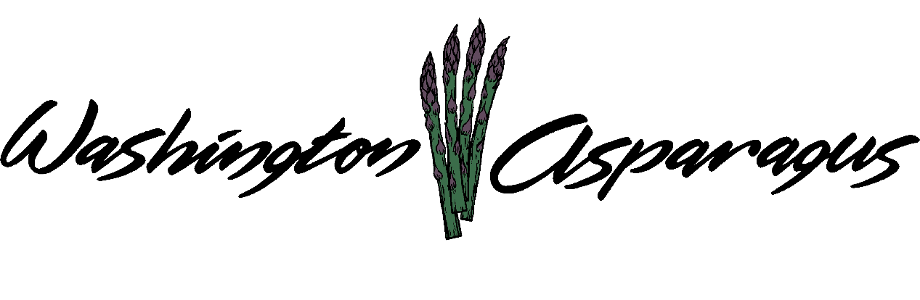

WASHINGTON ASPARAGUS COMMISSION

Asparagus Commission Office
Sunnyside, WA 99330
July 12, 2017
Gary Larsen, Chair, Presiding.

Chair Gary Larsen called the meeting to order at 11:00 am.

Introduction

Present: Gary Larsen, Steve Thomas, Norm Inaba, Jeff Muse, Gary Johnson, Rebecca Weber, Keith Middleton, Gary Johnson and Bryan Lynch.

Not Present: Jon Nishi.

Administration Staff Present: Alan Schreiber and Lori Anderson.

Guests present: Phil Klaus, Kevin Filburn, Ignacio Marquez from WSDA and Jim Middleton.

Approval of Minutes

Gary asked Rebecca about her thoughts on approval of the minutes, in terms of any changes particularly with the form of motion.

Chair Gary asked for a motion to accept the minutes.

Keith made the motion to approve the March 12, 2017 minutes, Jeff seconded the motion. Motion passed unanimously. .

Financial Report

Alan goes over all the expenditures as of July 6, 2017. What we have spent and what we have left over. The year is half way over and we have spent half the funds.

Not all the assessments are in, the amount collected at this time is $190,208.25. We have $155,847.35 in the checking account and a total of $101,077.04 in three separate CDs.

Check Detail

Alan went over all the checks written since the last commission meeting.

Chair asked for a motion to pass the financial report.

Norm made the motion to approve the financial report. Bryan seconded the motion. Motion passed unanimously.

PMA

This year it is in New Orleans, Louisiana in October. Gary and Alan would like someone from the Commission, or someone who is very involved in the industry to attend.

Jeff asked about Travis Nelson in regards to paying assessment; Lori will get with Jeff Muse and get his information.

Local Promotions

Gary told the Commission about the Asparagus Festival held at Middleton’s. The number of people attending were about the same as last year, but it was a different set of people, so we involved new viewers. The Committee is getting ready for next year and is asking for any individuals to volunteer and input information. Gary also brought up the Capital Hill Beef Day, and how we need to be prepared for next year.
Alan tells about the SCBG that the Asparagus Commission received, this money will go directly for our Promotion of Washington Asparagus. The total amount is $120,000, divided over the next three years, it will be used to expand to the greater Spokane and Boise Idaho area. The goal is to have one in seven people buy one more pound per year. The increase in sales would be a boost for the Washington asparagus industry.

Erik called in with a Section 18 regarding Warrior, Alan explained that the state regulatorsare waiting for EPA to get the label approved. Once it is approved Schreiber will distribute to all asparagus growers.

Evado PR
Heather and Lauren called at 11:30.

The media was utilized towards the Portland and Seattle areas. Evado included all other advertising that had been done throughout the State. Lauren talked about the social media campaign, this included organic and conventional asparagus Her thoughts about the campaign is that it reached a much larger population that originally thought.

Alan asked for an explanation of what they could have done if they would have had the green light in October of last year. Evado would have pursued magazine’s advertisement, grocery store ads, and other items that need three months advanced notice before the actual sale of Washington asparagus. Heather asked the Commission if they had thought about targeting the East partof the United States. She also brought up chef representations should begin much earlier.

Alan asked about the cost for 2018, Evado said that will depend on where we want to expand the market. Gary asked about the outside market, the East coast, if we could do this early in the season. How would Evado do this? Heather brought up media outlook, social media and other types of media. This would be a big cost because it is considered a new area to concentrate on. The main focus would be on the difference between Washington and Mexican asparagus. Alan asked the Commission have their plan together by October of this year to start the campaign for 2018. We will have a promotions meeting, this will include Evado. Call ended at 11:45

Rebecca would like to clarify the PR company’s contract term for next year. It is over, as of the end of July, so the Commission needs to make a decision on how to approach next year.

Gary wanted to know if we could make a choice today. Alan thinks that Evado is doing a good job, so we could produce an amendment to the current contract.

Alan and Gary explained to the Commission that we can see how the East Coast would respond, then adjust our mission. Alan asked the Commission about a motion to use the Promotions Committee to discuss this and have a more specific game plan.

Jim Middleton believes that since there is a limited amount of money going to promotions that we need to focus on the NW area only.

Who is going to be assigned to the promotions committee and have a phone call to a Evado?

Rebecca made a motion that the Promotion Committee be authorized to select the PR company for the 2018 Year. Bryan seconds the motion, motion passed unanimously

Bryan asked if there could be a review of all activities that Evado has done, and if it could be presented to the promotions committee

Trade Talks

Alan goes over a letter that the US international Trade Commission sent out to the asparagus industry regarding investigation of the Tariff Act. This is because of the surge of Mexican asparagus coming into the United States.

Why the season went as it did, Steve tells the Commission that after Mother’s day the Mexican grass started coming into the area, causing Washington asparagus to drop in price. Jim has heard that there is a new region from Mexico that is specifically targeting our growing season.

Other Business

The Assistant AG has not heard back from Mr. Whitman. We generally have to wait one year to dismiss the suit from the last bit of activity.

Not all the assessments are in at this date. Alan tells the Commission that the difference between this time last year and now is the weather. May was the busiest month of the year for cutting asparagus. Alan believes we will be up a million pounds over last year.

CD information Update: Alan went to Columbia Bank and they will be changing the Commissions CD’s to change the interest to 1.25%, 1.36% and 1.5%. This will increase our income slightly.

How do we enlist asparagus handlers into our marketing efforts? Jim is already ordering rubber bands for next year. Gary wants to know if we want to make it a requirement to put Washington Asparagus on the Bands. This will distinguish our asparagus from all the rest at the grocery store. How do we approach this, contact every handler and see how they feel about it. We cannot enforce handlers to do this, but it would be beneficial for all handlers.

Do we do make this a policy, that the Washington Asparagus Commission encourages all handlers to use rubber bands to include that say it is a product of Washington State?

Research

Jim and Steve want to know if overhead watering during the hot weather cools the asparagus off.
Is this a project that Alan can do? Gary Larsen tried it on his Millinuim asparagus this year and it worked very well for him. Alan can do this if the Commission wants him to.

The layby research project is in progress, Alan believes this is program that may bring new products into use by the asparagus industry.

Field Day
Date: September 13, 2017

Alan talked to the Commission about the international asparagus Symposium in Germany this year. He would like to go to this event, and it would be covered by the operation budget.
Chair Gary would like to know what the Commission will be getting out of it. Alan responds that he will find out about world research that has to do with asparagus. Rebecca would like a report when he gets back, Phil agrees. Norm and Bryan believes that he should go.

Mechanized Harvesting

Haws Harvester started operating this year, not the whole year, for one week in California. It did not go over well. We invited Joe and Kim to the meeting but we did not hear from them.

Keith used half of the carts he bought throughout the season, six workers want them back next season. Same speed as by hand, not anymore pounds but that was not the point. Overall, the harvesters were not successful

Legislative

At this time there is nothing legislatively impacting the asparagus industry except the Family Leave Act. Jim Middleton feels that the wages are a real problem, taking money out of the bottom line, so how should we respond to this. Alan will ask Charlie to address the state with solutions on how minimum wage increases affects the asparagus industry. So Alan would like to do something for the growers, because the packers will be out of business if growers go away. Automation and efficient machines in the packing division are the only way to deal with the minimum wage increase.

National Asparagus Council

California is very depressed, because of inferior quality and all of the Mexican asparagus that flooded their season. Michigan market was also impacted by Mexican asparagus. Cher Watte (California Asparagus Commission) is doing research on information trade assistance programs to understand why this is happening. They are working on a draft letter for a nine month study.

The International Trade Commission will be paying for this study. Mexico will be aware of how we are going to look at their import methods. Senator Cantwell is on the Ways and Stays Committee, so this is who we would contact.

Alan asked if California, Michigan and Washington would like to go in on a SCBG regarding promotion of USA Asparagus.

Commissions Positions

Keith Middleton has resigned from Position #2 as he is moving to Bend Oregon.
Alan went over the requirements to fill his position. Bryan asked if they have to grow in the district that they represent, Alan believes they do. Between now and the next meeting we need to find a replacement. Gary asked about changing this rule, Alan will look into this.

Labor

Workers are making more money working in the field, because there is no overtime in the plant.

Public Comment

Ignacio asked about the harvester, comparing this to the apple industry. He commented that our workforce is very efficient here and will often out-produce mechanization.

Gary asked about the start time for the upcoming WAC meeting. We will have the start time at 11:00 on all upcoming meetings.

Rebecca shared that overseas buyers are meeting in Yakima on July 18, Rebecca would invite anyone interested to participate. . For information on this contact Rebecca.

The Executive Director contract also needs to be rebid. A committee was established to handle this process comprised of Gary Larsen, Rebecca Weber and Jim Middleton. The committee will work on details between now and the next meeting.

Chair Gary asked for an adjournment of the meeting.

Norm made the motion to adjourn the meeting. Steve seconded the motion.

Meeting Adjourned at 3:50 pm.

