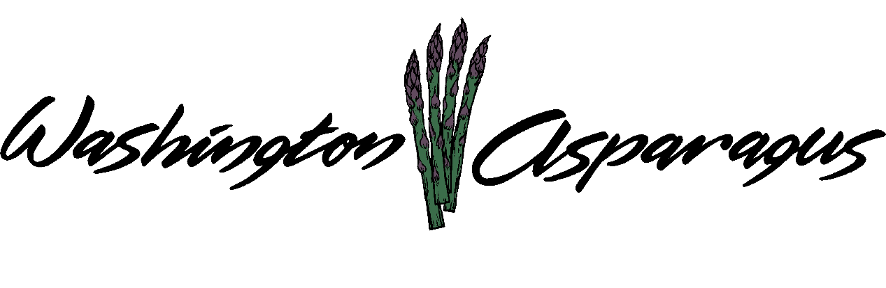

WASHINGTON ASPARAGUS COMMISSION

Asparagus Commission Office
Sunnyside, WA
March 30, 2016
Gary Larsen, Chair, Presiding.

Chair Gary Larsen called the meeting to order at 1:00 PM

Introduction

Present: Rebecca Weber, Steve Thomas, Jeff Muse, Gary Larsen, Gary Johnson, Jeff Muse, Keith Middleton, Bryan Lynch and Gary Johnson.

Administration Staff Present: Alan Schreiber, Lori L. Anderson and Tiffani Deal

Guests: Wendy Cordewell, Phil Clouse, Kevin Oldenberg, Bill Middleton, Jim Middleton

Approval of Minutes

Jeff Muse corrected a typo in the minutes.

Chair Gary Larsen asked for a motion to pass the corrected minutes.

Keith Middleton moved to pass the corrected minutes, Gary Johnson seconded the motion. All approved. The motion passed unanimously with corrections

Financial Reports

Alan reviewed the current WAC Budget and Expenditures prepared as of March 26, 2016.

Alan reviewed the current checks written.

Jeff Muse noticed a date error on the budget, he asked for a correction.

Gary Larsen asked for a motion to approve the current financials.

Bryan Lynch moved to pass current financials. Jeff Muse seconded the motion. Motion passed unanimously, with a correction.

Research
Field research on asparagus is underway at this time, data collection has just started..

Mechanization
Keith presented a video from Ken Wall of a single cart machine. The getting a machine here is taking longer than he originally thought but they are getting close to having a cart. Jeff is securing two carts from Europe that are similar to the type Keith is getting from Canada but are electric. Kevin Oldenberg shared his thoughts on what his ideas are for the different types of carts he was shown. New or old fields make a difference, width of rows, and if the fields have GPS than there would be no need for a driver are all factors to consider.

Bill Lund also has a machine called a Gieger-Lund Harvesting machine. Alan provided an updated picture and information on the machine.

Trade and Legislative

Charlie Brown provided an overview of the legislative session via a phone call. He spoke at length about a failed attempt by the Washington and Oregon Departments of Ecology to work on a joint effort to determine the carbon footprint of food processing facilities.

Labor- Alan asked if there was adequate labor for harvest. Gary Larsen is optimistic that he has enough workers. Jeff Muse thinks the higher pay rate will bring out more pickers and he thinks he has enough workers. Bill Middleton thinks the same as Gary Larsen, hoping that within a few days of asparagus harvest that enough pickers will show up.

Gary Johnson thinks the high wages paid to employees of hop growers had attracted workers who might have once picked asparagus.

Phil states that Gourmet Trading is doing well at attracting workers

Chair Larsen: Do we know what the industry is paying per pound? Jeff Muse stated maybe .30 cents for net and .25 cents for gross.

Michigan/California/Mexico Production Report

Michigan has a significant amount of processed asparagus in storage; the state produced 20 million pounds in 2015 and produced more fresh asparagus than processed asparagus for the first time in memory. There is a down turn in consumption of canned asparagus and the processors are expected to buy less, and as a result the industry is doing more to promote fresh sales of asparagus.

California is on the downhill side of their production period and past its peak, therefore they will not have a big impact on our market. By the 10th of April, Mexico will be finished with asparagus harvest, then the price should start showing some movement in the market after that date.

Market/Education Report

Tulare, CA
No Washington asparagus grower expressed an interest in attending the Tulare Ag Show so the WAC sponsored trip was cancelled.

The Promotions Committee is helping promote industry awareness, meeting every two weeks with Chair Gary Larsen, Keith Middleton, Jeff Muse, Tiffani Deal and Rebecca Weber. For the month of May, Tiffani is going to attend Food Truck Fridays to distribute asparagus to the food truck vendors to use in their products to promote Washington Grown Asparagus.

Country Mercantile is sending out information to different sites to promote asparagus sales.

Asparagus Fest and Brews is still under consideration, with Keith donating the Middleton’s facility on the Kahlotus Hwy for the event. There will be local food, beer and wine, this is a meet and greet, deep fried asparagus will be served and two food trucks will be there. There will be tours of asparagus fields with growers giving presentations on the tour.

As the date gets closer the committee will discuss further issues such as liquor license, how we are advertising, etc. Bryan Lynch wanted to make sure that everyone knows this is open to the public.

WAC is the only sponsor at this time, Alan wanted to know the cost to the Commission, and Gary Larsen estimated the dollar amount of $1,200.

Rebecca is concerned about liability issues and do we have insurance? Keith stated that there is insurance for the event.

Jeff Muse is working with a designer to design a costume to be worn at upcoming WAC events.

PMA is in Orlando Florida in October. There is a large asparagus trade show in Europe, dates are November 16 & 17, 2016. We are seeking candidates to go to PMA and will select a person or two to go to the German asparagus trade show.

District Report

Columbia Basin: Bryan Lynch is getting ready to harvest, Keith Middleton has already started harvesting.

Yakima Valley: Gary Johnson will started cleaning up his fields this coming Friday, it will be ten days out before they start harvest.

Other Business

Alan brought up information regarding the Open Public Meetings Act. The state passed another law regarding this information. It is very important that the rules of this Act are followed.

EPA is very aggressive on pesticide issue; Alan signed the WAC on to an amicus brief regarding an insecticide.

Each year Schreiber has submitted a Section 18 for Warrior II. There is a chance to pursue a different and probably a more effective aphid insecticide called Transform. Schreiber described the relative merits of both products and asked the board which to pursue. The board indicated the Schreiber should use his judgement on which product to pursue.

Schreiber described going to the meeting earlier in the week. Derek Sanderson is the new Director of Agriculture and he is making a point to meet with ag groups.. Rebecca stated that he is working really hard with the policies and doing a good job. Some of the things he has done within the Department of Ag is improve communications, oversite of projects and the nomination payment process.

Adjourn

Chair Larsen asked for a motion to adjourn the meeting.

Keith Middleton moved to adjourn the meeting. Gary Johnson seconded. The motion was passed unanimously.

