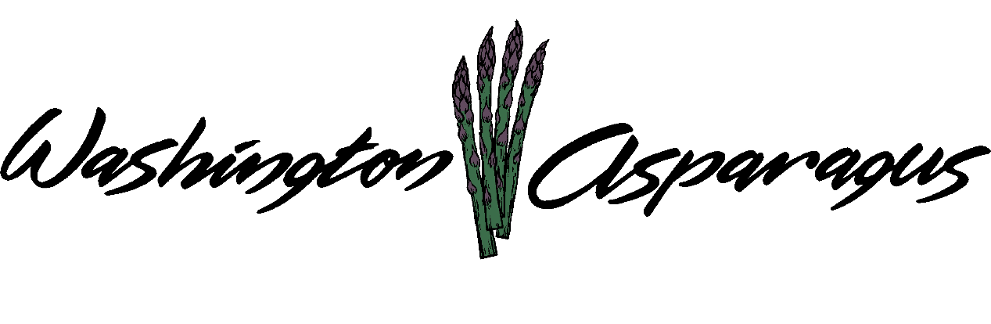

WASHINGTON ASPARAGUS COMMISSION

Asparagus Commission Office
Eltopia, WA 99330
October 26, 2017
Gary Larsen, Chair, Presiding.

Chair Gary Larsen called the meeting to order at 1:00 pm.

Introduction

Present: Gary Larsen, Steve Thomas, Norm Inaba, Jeff Muse, Rebecca Weber, Gary Johnson, Jon Nishi and Bryan Lynch.

Administration Staff Present: Alan Schreiber and Lori Anderson.

Guests present: Bill Middleton, Jim Middleton, Zach Miller, Phil Klaus, Sandy Lehrman.

Approval of Minutes

Gary asked Rebecca about her thoughts on approval of the minutes.

Chair Gary asked for a motion to accept the minutes.
.
Gary Johnson made the motion to approve the minutes. Bryan Lynch seconded the motion. Motion passed unanimously. The minutes are from July 12th, 2017.

Expired Terms

We have two terms that have expired, Norm Inaba and Gary Larsen. The Department of Ag sent out letters to the asparagus industry. Norm and Gary have been re-nominated, but we have a vacant position in the Walla Walla District. Three names have been brought to Alan’s attention, Travis Meacham, Zach Miller and Bill Middleton. Zach and Travel has been in the industry for 4 years, neither of these growers grow asparagus in the Walla Walla District, but Bill Middleton grows and in this district. Between the three candidates, one is qualified, the other two are not qualified to be on the commission as the requirements is that a board member needs to be in the asparagus industry for five years before serving. Alan asked the Commission if they want to nominate Bill, but Chair Gary wants to discuss the RCW changes before the Commission decides, the change is regarding consolidating the Walla Walla District into the other districts.

Financial Report

Alan went over all the checks written since the last commission meeting. These include operating costs, marketing, International Asparagus Symposium trip, and administrative fees.

Assessments have been received for the 2017 year. There was more asparagus grown this year than last year, Alan was surprised by how much was produced in 2017. Alan then went over the Check Detail. Chair asked for a motion to pass the financial report.

Gary Johnson made the motion to approve the financial report. Joh Nishi seconded the motion. Motion passed unanimously.

Assessments

Alan explained about the collection of the assessments this year. The total collected was $199,617.92, this being the most asparagus grown since 2009. Alan explained the late fees due on assessments, and how the Commission should deal with this. The main issue with not collecting the late fee is that during the audit we get a finding. Alan would like the Commission to either come up with a change, or leave it the way it is and be prepared to accept the SAO findings. Norm asked about an extension, would this help with a finding, especially if there is financial difficultly.

2018 Budget

According to the projections the budget will stay the same unless there are changes the Commission would like to make. Alan went over all expenses for the 2018 year, he took out the budget line for harvest mechanization, but if the Commission would like this put back into the budget let him know. Alan needs the Commission to either adapt this budget or come up with a different one, this needs to be done within the week for the Washington State Department of Agriculture.

Marketing Education

Bill Middleton will continue with the Asparagus Festival, the Marketing committee will continue working on this. Gary Johnson and Steve Thomas would like to continue with the promotion of asparagus on the East Coast. Evado gave a list of dates for the time line of promotions. Gary would like Alan to check on these dates to make sure they are beneficial. Norm believes the earlier the better for marketing, Gary Johnson agrees. Alan believes that the areas we are targeting with Washington asparagus promotions will not conflict with the marketing efforts of other asparagus growing regions.

Research

Jim Middleton wanted to do a research project on the use overheard watering to cool off asparagus in hot weather periods during harvest. Bill had an idea regarding nightshade control. . Bryan would really like to find an answer for the bindweed. Alan asked about who would like to be on the research committee, Jim Middleton, Bryan Lunch, Jeff Muse, Norm Inaba and Zach Miller will be on this team.

Trade and Legislative

Peru asparagus imports were way down this year due to several issues. Mexican imports had a severe impact on Washington asparagus in 2017. For example, Jim Middleton was informed by his buyer to stop packing his asparagus in May due to imports. There was extensive discussion on how do we compete and how do we respond to the rapid increase in imports from Mexico during our window. Phil Clouse provide data on asparagus movements during our harvest window from California, Michigan, Washington, Mexico and Peru. In the past four years, Mexican imports have increased by 400%. Steve believes that Washington State is the next state to be targeted by the Mexico and Peru asparagus. This has already happened to California, Bryan and Gary Larsen agree.

Charlie Brown- State Issues

Charlie called in at 2:30 pm to discuss the state legislative issues. He feels we need to wait till after the November election to see if the Democrats or Republicans take control of the house.
Bryan asked about Benton and Franklin County water issues (the Hirst decision). Since both counties are on the East side of the state and there has been an initiative to halt digging of all new community wells. Alan asked Charlie if there is anything the Asparagus Commission can do anything to prepare for the 2018 year. The only idea Charlie could come up with is marketing fresh asparagus in all areas of the state. Matching funds from the Washington State Department of Agriculture may be available to help with marketing of fresh Washington asparagus during the season.

New Business

Annual Meetings for 2018

January 17th Prosser, WA.
March 28th Eltopia, WA
July 18th Sunnyside, WA
Oct 10th Eltopia, WA

Enabling Legislations

The Commission would like to discuss making changes regarding the Walla Walla District, should we keep this position open or change the RCW to combine the district with an at large position, Norm suggested this. Meaning anyone from Position 1 or 2 can fill this position since most of the growers are in the Yakima and Columbia Basin. We are rewriting the RCW regarding the minimum age of an applicant and how many years of experience the individual has before they can be on the board. We are changing the term limits, and is striking the section regarding WSU overseeing all the research projects. There will also be a change to the RCW regarding late assessments. Assessments due by the end of August, if no payment by September 30th then a 10% late fee will be assessed.

Other Business

The lawsuit against the WAC could be eligible for dismissal as of February 28th of 2018 if there is no further communication with Mr. Whitman.

The Administrative Services Committee recommended to the board to continue with the contract with Alan Schreiber doing business as Agriculture Development Group, Inc.

Rebecca moves to accept Ag Development Group as apparent successful vendor and the board grant authority to the committee to complete the contracting process. Norm seconded the motion. All in favor of the motion. Motion passed unanimously.

Chair Gary asked the Commission about Bill Middleton.

Norm made the motion to accept the nomination of Bill Middleton to represent District 3. Steve seconds it. All in favor of the motion of Bill Middleton being named to the board. Motion passed unanimously.

Alan is concerned about the increase of organic asparagus grown in Washington State. There is a feeling among organic growers that there should be a concern about the influx of organic asparagus in the upcoming year. Norm brings up that this is what has happened to conventional asparagus. Alan would like to schedule a meeting to further discuss this. The Commission would like Alan to continue researching this and schedule it for the agenda in January.

What topics does the Asparagus Commission want Alan to discuss at the January Meeting?
Organic asparagus, state of the industry, marketing and end user buyers.

Gary asked about the rubber bands. Gary askes the Commission what they think, Yes, we will include the entire state of Washington asparagus growers in the RCWs.

Public Comment

There was no public comments.

Gary Larsen asked for a motion to adjourn the meeting.

Norm made the motion to end the meeting. Bryan seconded the motion. All approved. Motion passed unanimously.

Meeting Adjourned at 4:20 pm.

